NHS National Services Scotland – Driving Sustainability Through Strategic Procurement
Contents
Background and Requirement 1
National Procurement and Sustainability. 1
This case study. 2
Developing the sustainable procurement focus 2
Feedback and review 3
Strategic sustainable procurement prioritisation 4
The Procurement Process 5
Applying results to processes. 5
Frameworks supported 6
Successes and outcomes. 7
Lessons learned. 9
Prioritised focus 9
Utilise, often limited, resources effectively 9
Maximising outcomes 10
Raising the profile of sustainability 10
Positive consultation, collaboration and partnerships 11
Working to develop across NHS Scotland 11
Use tools and resources available 12

Background and Requirement

National Procurement and Sustainability.
National Procurement is the Centre of Procurement Expertise for the NHS Scotland (NHSS), providing expert advice and support to Health Boards (HBs) on procurement matters. National Procurement manages over £1.44 billion annually in national contracts, for goods and services used within our hospitals and health services, including pharmaceuticals, medical devices, waste services, food and specialist professional services.
In support of the NHS Scotland commitment to becoming a net-zero Healthcare Service by 2040 and supply chain achieving net-zero emissions by 2045, National Procurement frameworks and commodity strategies are evolving to include sustainability considerations. Harnessing these opportunities drives progression towards targets through collaborative and contractual engagement with suppliers. This strategic approach conveys clear commitment to the wider organisation, suppliers, industry, and the public, highlighting its responsibility in tackling global climate change.
Since April 2025, the National Procurement Governance and Sustainability Team has offered support to selected National Frameworks to maximise sustainability considerations by including and supporting evaluation of bespoke sustainability criteria.

This case study.
This case study explores the strategic planning and analysis that has resulted in the focus on selected frameworks, and ongoing process and governance.
The intended audience for this case study comprises:
- Senior NHSS stakeholders including service managers;
- Medical directors & clinicians;
- Climate and Sustainability specialists;
- Procurement practitioners in public bodies

Developing the sustainable procurement focus
Trialled approach – a ‘Model Question’.
National Procurement sought to enhance the inclusion of sustainability within frameworks and commodity strategies:
- To ensure, where relevant, alignment with UK Healthcare partners, to help ensure a clear and consistent message to suppliers, industry and relevant stakeholders.
- To support targets such as the transition to Net Zero.
- To help procurement teams.
As a result, in 2023-2024, to ensure sustainability consideration in tenders for consumable product commodity frameworks, the inclusion of a ‘Model Question’ was trialled in selected frameworks, with a set of environmental questions and guidance for their evaluation. The question for bidders focused on mitigation of climate impacts throughout the relevant product life cycle.

Feedback and review
A series of engagement sessions were held internally and externally (facilitated by industry groups) ahead of the trial and feedback was sought post-trial.
Following evaluation of this trial, the decision was taken not to roll out the Model question further. The question was considered too generic as it limited inclusion of specific risks, making it hard to score, and it also stifled innovation as it didn’t fit well in the scoring methodology.
Instead, in order to ensure continual improvement in sustainability, a range of opportunities have been routinely applied:
- in particular, the need to apply a commodity specific approach, which suppliers have stated a preference for, allowing for relevant and proportionate questions to be asked around known environmental risks specific to those products and with support for both buyers and bidders to build confidence in this approach
- use of the national sustainable procurement tools and supporting guidance to identify and assess the social and environmental impacts of procurements, and to embed relevant and proportionate sustainability requirements in the development of contracts
- supplier selection process – inclusion of Single Procurement Document (SPD) 4C7 to request Carbon Reduction Plans where relevant and proportionate
- supplementary information collation through Evergreen (NHS England’s sustainable supplier assessment), and the Modern Slavery Assessment Tool (MSAT), where relevant
- requirements for suppliers to operate to international environmental standard ISO14001 or equivalent and/or undertake life cycle carbon assessments of products applied only where this is appropriate to the requirement and market capability, enabling participation for SMEs and third sector organisations, while recognising the need over time to better understand the carbon impact of products supplied in a consistent, internationally recognised, manner
This renewed focus on sustainability, reflected in a strategic planning approach, will help ensure a balanced and structured approach to consideration of all relevant environmental and social risks and opportunities.

Strategic sustainable procurement prioritisation
The development of this strategic approach has involved:
- a balanced assessment of 75 forthcoming frameworks and their relevant environmental and socio-economic risks and opportunities, using the Sustainable Procurement Prioritisation Methodology, based on the National Procurement Workplan for 2025/6 to 2027/8
- frameworks assessed included NP68625 Orthopaedic Trauma & Extremity Implants, NP56425 Supply of Healthcare Beds & Mattresses, NP59725 Custom Theatre Packs and Speciality Packs & Drapes together with others from food, textiles, healthcare services, various consumables, devices and other products
- this resulted in a number of food, textiles, furniture, vaccine management and various consumable and product frameworks identified as initial priorities
- this assessment considered the environmental and socio-economic risks and opportunities, the scope to improve these within the frameworks and the extent to which National Procurement could reasonably influence market change. Additional factors were also considered to ensure a focus on appropriate frameworks
  - the timings of the frameworks, to reflect those that could be realistically influenced while accounting for spread to ensure effective support availability
  - the capacity and existing knowledge of strategic sourcing and procurement colleagues
  - compliance with emerging legislative changes and complementing other national sustainability initiatives
  - further research to fill gaps in knowledge identified during the initial assessment
  - the feasibility of support time available from Subject Matter Experts
  - Framework implementation – actions and outcomes

The Procurement Process

Applying results to processes.
This prioritisation assessment has been adopted in the service level matrix (Figure 1.) to support sustainability incorporation in frameworks, as part of a three-year work plan, to develop the embedding of relevant and proportionate sustainability into procurement.
This has impacted on procurement processes:
- category/Commodity Strategies - relevant environmental and socio-economic risks and opportunities, and suitable approaches, within the following
- the use of Sustainable Procurement Tools – as well as the use of the Prioritisation Methodology, targeted commodity specific sustainability requirements supplement understanding and use of the Sustainability Test and Life Cycle Impact Mapping
- pre-tender engagement with suppliers and markets - and also within commodity and category managers/teams. This includes the use of Prior Information Notices, highlighting the focus on sustainability within relevant frameworks
- collaboration within Commodity Advisory Panels - comprising representatives from relevant NHS boards, clinical and technical experts, and staff with expertise in specific areas, to provide expert advice and guidance on commodities or services being procured
- tenders, evaluation and award - appropriate requirements within tender specifications, evaluation and award criteria, while ensuring objective evaluation of these tenders
- the targeted commodity specific sustainability questions seek to progress performance against targets, mitigate risks and capture opportunities, such as increase circularity and improve resilience
- contract and supplier management - Post award engagement

Frameworks supported
The shortlist of frameworks to target is reviewed jointly with Heads of Commercial, category managers and Head of Governance, with the ultimate decision residing with Heads of Commercial. These will be reviewed 6 months in advance of each calendar year.
The number of planned priority frameworks supported in 2025/6 was 12, based on a pro rata maximum viable capacity for full prioritised support. However, it is understood that there will be a need for differing levels of input during the procurement process. This is reflected in the model below:
Figure 1: Supporting frameworks model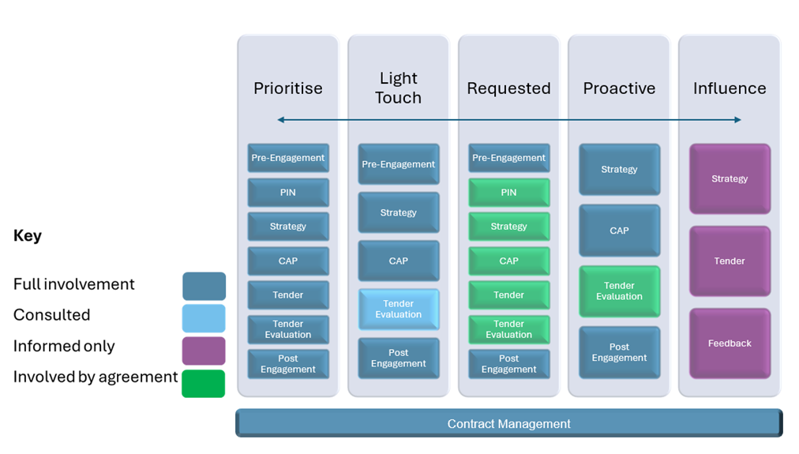
As a result, it is intended that 16 frameworks per year will be supported, subject to ongoing review, with the expectation that this may increase as commonality of approaches adopted across frameworks is identified.

Successes and outcomes.
This strategic planning approach has resulted in several positive outcomes:
- repeatable: it has established a consistent repeatable process
- strategy and continual improvement - the 3-year Commodity Specific Sustainability Strategy aligns with the NHS Scotland Climate Emergency and Sustainability Strategy and (2022-2026) NHS Scotland Procurement Strategy (2024 – 2028) - opportunities to reflect this in a Road Map setting out the journey to sustainable supply chains and Net Zero will be explored
- one of the frameworks included within this strategic approach was a high value framework with a duration of 15 years. This framework is the first with a timeline that falls within NHS Scotland’s first Net Zero target, this further strengthened the need to include sustainability considerations within the tender process to ensure mutual alignment to Climate goals
- strategic Sourcing and Commodity Teams - are increasingly engaged with sustainability, building knowledge and skills and seeking support, clarification and guidance
- focussed approach supports accessibility – the bespoke approach to sustainability considerations in tenders has been well received by suppliers, including SMEs. A number of SMEs have excelled in their responses, clearly indicating how their offerings align with the NHS Scotland’s sustainability targets
- sustainability weightings and their impact – these have been included in tenders where they have not been previously, determined on a case-by-case basis to ensure relevance and proportionality to the contract in question
- where they have been included, weightings have been maintained or increased , for example this includes a 40% sustainability weighting in the Examination Gloves framework, which has a significant impact given the quantity purchased annually
- bank of resources - this has resulted in resources, including question sets, tools, web resources and policy guidance to support knowledge sharing and best practise
- catalyst for further opportunities – supplier acceptance of the strategy has led to increased supplier engagement, with innovation and circularity in products being proffered
As a result of sustainability dialogue within a Commodity Advisory Panel (part of the strategic process), a Short Life Working Group has been established to look at processes to improve and increase circularity with walking aids.

Lessons learned.

Prioritised focus
- A strategic approach will ensure that effort is focused, and resource deployed, where the most productive opportunities are available. This allows for the effective use of often limited resources against identified ‘priority’ areas. The approach establishes respective priorities through a balanced assessment of strengths, weaknesses, opportunities and threats.
- Specific policy commitments can sometimes result in a focus on single issues within commodities, rather than an essential balanced assessment of all environmental and socio-economic risks and opportunities that ensures relevance and proportionality. Tailored requirements within tenders are the best way to ensure that this is met, improving compliance with national requirements and regulations.

Utilise, often limited, resources effectively
- Make sure available resources are used in a practical and prioritised manner.
- Don’t treat every framework or contract the same from a support perspective. This should reflect the variety in frameworks but also support requirements from the procurement team.
- Allow for knowledge of commodity managers and markets to be focussed on prioritised frameworks, and specific environmental aspects which will likely form part of supplier engagement.
- Focus additional knowledge and support where it can have the greatest impact.
- Ensure support for procurement colleagues in a practical way, while enabling them to develop and take ownership.

Maximising outcomes
- Commonalities across various frameworks enable replication of good practice and learned lessons by commodity managers. Inevitably, there are common issues in some frameworks, which may be under the same or similar category so there may be no need to reinvent sustainability requirements. This may be helped by use of the ‘local template Sustainability Tests’ with the Sustainable Procurement Tools platform.
- Continual improvement, based on implementation and learning within frameworks, collaboration across sourcing and commodities will support the maximisation of positive outcomes.

Raising the profile of sustainability
Collaboration, and the development of, sustainability across frameworks raises the profile and awareness of the increasing need to include climate considerations in modern procurement practices. This includes how circularity can support the resilience of NHS Scotland and supply chains, and how the reduction in breadth and range of procured items enhances sustainability and overall resilience.
In addition, implementing sustainability can result in patient benefits and systemic financial savings reflecting the ‘triple bottom line’ model. To further benefit and evolve evaluation, there is a need for Life Cycle Cost (LCC) to be embedded and considered in respect of direct and indirect costs under frameworks. Inclusion of these costs may refocus award decisions and positively impact NHS Scotland performance, environmental factors and the strategic direction of public sector procurement.

Positive consultation, collaboration and partnerships
There has been a positive response from suppliers, industry and markets to this structured approach on sustainability, with the potential to drive market change.
Communication and collaboration is key. To evolve and upskill the marketplace it is important that we collaborate within the industry and partners to align on mutual targets and goals. Establishing ambitions, understanding appetite and an awareness of capacity and capability to support these is essential.
Suppliers working in these industries are increasingly likely to be able to demonstrate their awareness and adherence to emerging improvements and technologies specific to the commodities that they are marketing. Consultation with suppliers will inform and support development in this approach. For example, where themes arise that may be suitable for wider inclusion these can be put through market consultation to inform policy.
This targeted approach supports a focus on emerging market risks and priorities, whilst providing an iterative process which can be refined and incorporated into other future tenders.

Working to develop across NHS Scotland
National Procurement works on behalf of, and collaborates closely with NHS Scotland Boards, as well as other public bodies and partners. This includes the provision of guidance, with a centralised viewpoint, with potential adoption of the same methodology of approach applied to local procurement practice.
Opportunities to develop this across NHS Scotland also include passive education through Commodity Advisory Panels and relevant Short Life Working Groups. This engagement helps to ensure visibility of this approach on a national and local basis, enhancing positive engagement and response, whilst driving adoption through demonstration of how this approach can support Boards.
Opportunities potentially exist for other public bodies to apply a similar approach, collaborating on practices and sustainability questions with National Procurement.
It is also important to keep the approach under review, identifying any challenges, further opportunities and outcomes delivered.

Use tools and resources available
This approach has utilised the Sustainable Procurement Tools and guidance that are available, tailored to suit the focus and aims of the strategy. The more these Tools are used the more familiar users become. There is further potential to align questions with prevalent risk areas as identified in the sustainability test within the Tools, ensuring that there is end to end support for procurement staff.

